How was your day?
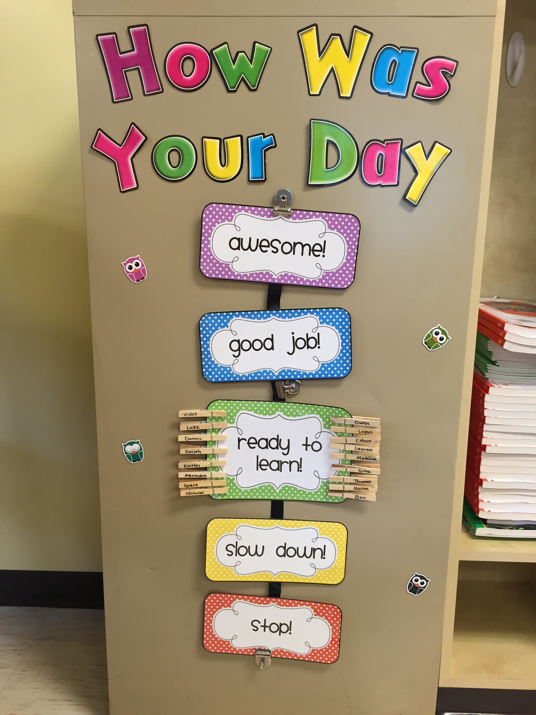
We will using a clip chart behavior plan this school year. Students will be able to independently move their clip to the appropriate color based on his/her choices. This will be a great way for your child to recognize consequences for not following classroom and school rules. If a student is making poor choices and has received two verbal warnings, he/she will be asked to move from the green card to the yellow card. If the student continues to make poor choices, he/she will be asked to move to the red card. The red card indicates that you will be hearing from me via a note or email. Moving to yellow or red also results in consequences relative to the action (i.e. saying something mean to a classmate results in a verbal apology). In the occurrence of a student physically hurting another student or any other more severe behavior, that child will instantly move to red and parents will be notified. On a positive note, students have the opportunity to move from the green to blue or pink. These cards will result in a raffle ticket. At the end of the month, I will pull raffle tickets for various rewards.
This year you will be able to track your child’s behavior using the interactive app/website called ClassDojo. Please see the attached the back of this page for more information.
As a whole class, we celebrate behavior using Warm Fuzzies. These are the puff balls used for crafts. Any time the class is caught on task and following rules they will earn Warm Fuzzies. Once the jar is filled, the students earn a special treat.
I hope this has been a helpful introduction to our individual and whole-class behavior plans. I encourage you to talk with your student about the behavior system as this will help us have a successful school year. So go ahead and ask, “How was your day?”
Thank you for your support and kindness as we kick off this school year.
Best Regards,
Mrs. Boyer

